GRACE CHRISTIAN ACADEMY
MOTHER’S MORNING OUT
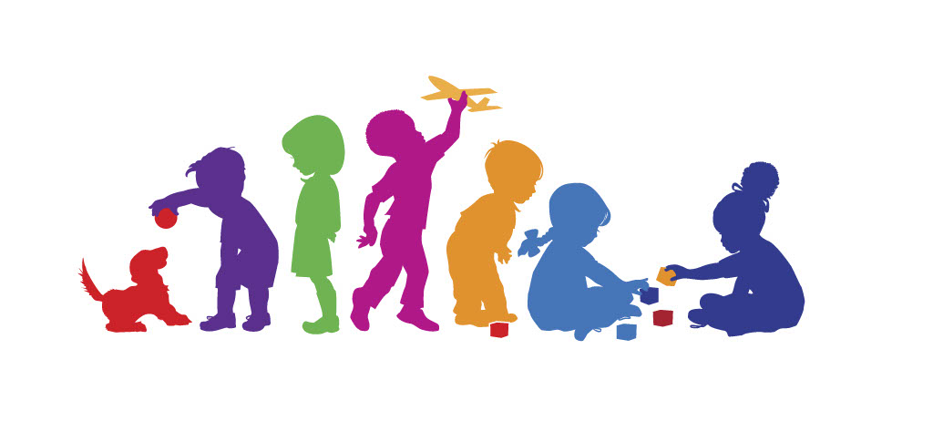

PARENT HANDBOOK
2022-2023

Our Philosophy
Grace Christian Academy Mother’s Morning Out was founded for the purpose of providing a Christ-centered, Bible –based, Christian education for all children. We strive to educate young minds in christ-centered curriculum. All units will be taught from a biblical perspective. The center has a positive, loving, and nurturing atmosphere. We believe the center is an extension of the Christian home. All our activities are planned for Christian growth and fellowship, as well as educational benefits.
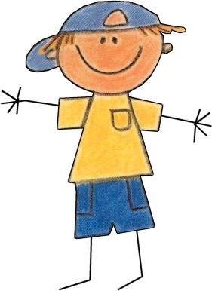
The staff will provide opportunities for every child to develop skills in sharing, taking turns, making friends, resolving conflicts, solving problems, helping others, recognizing, and accepting others, building self-esteem, strengthening emotional control, and experiencing growth towards self-discipline. Our qualified teachers have a strong faith in Jesus Christ and look to Jesus for guidance throughout each day.

Mission Statement
At Grace Christian Academy Mother’s Morning Out, we seek to nurture and minister to your child and family by displaying the love, mercy, and grace of Jesus Christ in everything we do. Our purpose is to prepare your child not only socially, emotionally, physically, and intellectually but more importantly spiritually, equipping them to succeed in everything they do.

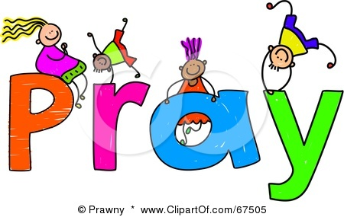

Notice of Nondiscriminatory Policy
The Grace Christian Academy Mother’s Morning admits students of any race, color, national and ethnic origin, sex, etc… to all the rights, privileges, programs, and activities generally accorded, or made available to students at the school. It does not discriminate in in administration of its educational policies or admissions policies. In accordance with Federal Law this institution is prohibited from discrimination based on race, color, national origin, sex age or disability.

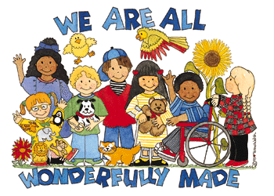

Daily Schedule

9:00 a.m. – 9:20 a.m. Free Play
9:25 a.m. – 9:55 a.m. Circle Time

10:00 a.m. -10:20 a.m. Snack Time

10:25 a.m. -10:55 a.m. Table Time
11:00 a.m.-11:20 a.m. Recess
11:25 a.m. – 11:55 a.m. Bible Time
12:00 p.m. -12:35 p.m. Lunch

12:35 p.m. – 12:55 p.m. Music/Clean Up
1:00 p.m. Dismissal
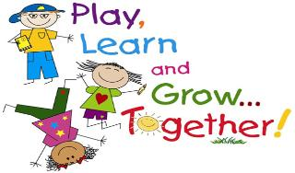

FEES
Payments may be made through the brightwheel app with a card or you may pay cash or check.

Registration Fee
An annual, $75 non-refundable registration fee will be charged for each child for the school year.
A Supply Fee will be charged for each child for the school year. The fee is $100 for the year. $50 is due by September 15 and $50 is due by January 15.
Tuition
Tuition is paid monthly. Any payment arrangement must be made in the office with the approval of the Director. Accounts that become delinquent after 1 month, the child will not be permitted to return until the account is paid. If parents have an outstanding account with the center, their child will not be admitted for another school year until the balance is paid.
Tuition for the 2022-23 school year is as follows:
Two Days – Tuesdays/Thursdays $175.00
Three Days – Mondays/Wednesdays/Fridays $200.00
Five Days – 3’s and 4’s Only $250.00

If your child is absent from the center or if the center is closed for holidays, snow days, emergency days, teacher workdays, etc., tuition payment is still required. ALL FEES ARE NON-REFUNDABLE.

Authorization for Child’s Release
Children may be released ONLY to parents, legal guardian(s), or persons who have been specifically authorized(listed on application) to pick up the child. If a person shows up and is not listed as an authorized person to pick up, the child will not be released to that person. You may not call and give someone permission. The person must be on your written list. Please make sure you list everyone that may need to pick your child up. . A picture ID may be required. PLEASE DO NOT SEND ANYONE UNDER THE AGE OF 18 TO PICK UP YOUR CHILD.

Late Pickup
A late pickup fee will be charged to your account at the rate of $2 per minute if you should pick up your child from the Center after 1:00 p.m. If you know that you will be late for pickup, please notify the Center on the day you will be late before pickup. A late fee will still be charged
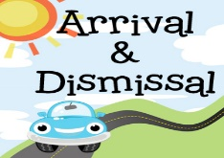

Arrival and Dismissal
Sign In/Out: Upon arrival, the staff will sign your child in through the brightwheel app. An adult must accompany all children inside the facility. NEVER LEAVE YOUR CHILD UNATTENDED! When you return for your child, a staff member will sign the child out on the brightwheel app.

Days and Hours of Operation
The center operates Monday-Friday year-round, from 9:00 a.m.-1:00 p.m. except for the days and holidays listed on the calendar.

GCA Mother’s Morning Out 2022-23 Calendar
Aug. 30 Orientation for Preschool 6:30
September 6 First Day of MMO
September 5 Labor Day – Holiday -MMO Closed
Nov. 11 Veteran’s Day-MMO Closed
Nov. 23-25 Thanksgiving Holiday -MMO Closed
Dec. 21-Jan. 4 Christmas Holiday – MMO Closed
Jan. 3 Classes Resume
Jan. 16 Martin Luther King Holiday
Feb. 20 President’s Day Holiday
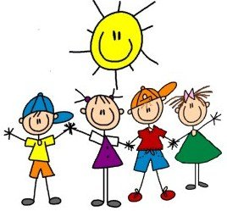
April 7 -14 Easter Break-MMO Closed
May 26 Last Day of MMO

Inclement Weather Policy
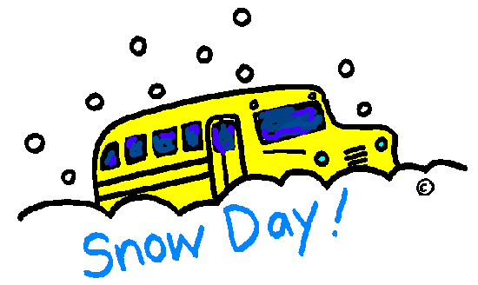
In the event of inclement weather, the center will follow the Cleveland County School Closing.
The center reserves the right to close for repairs, workshops, and conferences. Advance notice will be given when possible.

HEALTH, SAFETY, AND EMERGENCY PROCEDURES
The staff will keep a file indicating how to get in touch with parents, who to call if parents are unavailable, and the name of your child's physician, hospital, and dentist. Please keep these numbers up to date. If your address or telephone number should change, please notify the Office staff. Always leave a number on the Sign In/Sign Out sheet and in the Office where you, or someone you designate, can be reached in case of sickness or an emergency. If your child requires medical attention due to an accident that occurred at the Center:
• A car is always available for emergency transportation.
• Staff must be able to identify persons authorized by the parent to take the child from the Center.
• The Center maintains a phone number list where emergency contacts may be reached.
• Emergency telephone numbers are posted by the phone for fire, police, ambulance, and rescue squad.
• If your child should require medical attention, please bring the medical report to the Child Care Center Office the following day.
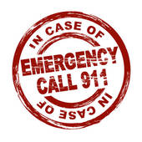

Prevention of Shaken Baby Syndrome and Abusive Head Trauma
Grace Christian Academy believes that preventing, recognizing, responding to, and reporting shaken baby syndrome and abusive head trauma (SBS/AHT) is an important function of keeping children safe, protecting their healthy development, providing quality childcare, and educating families.
Background
SBS/AHT is the name given to a form of physical child abuse that occurs when an infant or small child is violently shaken and/or there is trauma to the head. Shaking may last only a few seconds but can result in severe injury or even death. According to North Carolina Child Care Rule (childcare centers, 10A NCAC 09 .0608, family childcare homes, 10A NCAC 09 .1726), each childcare facility licensed to care for children up to five year of age shall develop and adopt a policy to prevent SBS/AHT.
Procedure/Practice
If SBS/AHT is suspected we will observe a child for sign which include irritability and/or high-pitched crying, difficulty staying awake/lethargic, loss of consciousness, difficulty breathing, inability to lift the head, seizures, lack of appetite, vomiting, bruises, poor feeding/sucking, no smiling or vocalization, inability of the eyes to tack and/or decreased muscle tone. Bruises to look for are on the upper arms, rib cage, or head resulting from gripping or from hitting the head.
Also, if SBS/AHT is suspected:
- Call 911 immediately upon suspecting the abuse and inform the director.
- Call the parents/guardians.
- If the child has stopped breathing, trained staff will begin pediatric CPR.
- Instances of suspected child maltreatment in child care are reported to Division of Child Development and Early Education (DCDEE) by calling 1-800-859-0829 or by emailing webmasterdcd@dhhs.nc.gov.
- Instance of suspected child maltreatment in the home are reported to the county Department of Social Services 704-487-0661.
Prevention Strategies for staff dealing with a crying, fussy, or distraught child:
Staff should first check to see if the child has any physical needs such as, hungry, tired, sick, or needs a diaper change. If no physical need is identified, staff will attempt one or more of the following; rock the child, hold the child close, walk with the child, stand up hold the child close, sing or talk in a soothing voice, rub or stroke the child’s back, chest or tummy, offer a pacifier or try to distract the child with a toy, take the child for a ride in a stroller, turn on soft music. If staff feel frustrated, an immediate break is allowed. If we see a parent becoming frustrated with a child, we will kindly offer support and ask if we can help with the child and allow the parent a break.
Behaviors that are prohibited are shaking or jerking a child, tossing a child into the air or into a crib, chair or car seat, pushing a child into walls, doors or furniture.

Parent web resources
- The American Academy of Pediatrics: www.healthychildren.org/English/safety-prevention/at-home/Pages/Abusive -Head-Trauma-Shaken-Baby-Syndrome.aspx
- The National Center on Shaken Baby Syndrome: http://dontshake.org/family-resources
- The Period of Purple Crying: http://purplecrying.info/

Facility web resources
- Caring for Our Children, Standard 3.4.4.3 Preventing and Identifying Shaken Baby Syndrome/Abusive Head Trauma, http://cfoc.nrckids.org/StandardView.cfm?StdNum=3.4.4.3&=+
- Preventing Shaken Baby Syndrome, the Centers for Disease Control and Prevention, http://centerforchildwelfare.fmhi.usf.edu/kb/trprev/Preventing SBS 508-a.pdf
- Early Development & Well-Being, Zero to Three, www.zerotothree.org/early-development

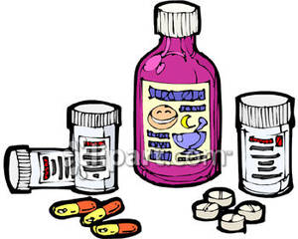
Medication
Our licensing regulators have suggested that we keep as little medication as possible in the center to provide a safer environment for children. Please ask your child's physician to prescribe medicine to be given before and after the hours that your child will be in our care, if possible. The following information comes from the NC Day Care Licensing Handbook and will be the procedure used at the Center. All medication for children enrolled in MMO must have specific instructions and written permission for administering medication. Instructions must be completed by either the parent or a physician and must include the following: 1. Child’s name. 2. Name of medication. 3. Amount of medication. 4. Frequency of medication. NOTE: INSTRUCTIONS MUST BE SPECIFIC - DO NOT USE THE WORDS "AS NEEDED" ON THE FORM. 5. Length of time the medicine is to be given. 6. Signature of parent.
Prescription Medication
- Must be in original container bearing the original label. Must have complete instructions on the label or be accompanied by written instructions from a health professional, which include 1 - 6 above. 2. Must be administered only to the person for whom it was prescribed. 3. Cannot be administered after its expiration date.

Over-the-Counter Medications
1. Should have the individual child's name written on the bottle.
2. Must have written instructions from the parent or physician. 3. Must have written permission from the child's parent. 4. Can be administered only to person specified in written instructions from the parent. 5. A doctor must give instructions about dosage if the dosage conflicts with the instructions on the patient medicine bottle. The correct dosage amount for your child's age must be clearly listed on the bottle. 6. Medication cannot be administered after the expiration date.
Instructions must be followed when administering all medications. Medications must not be administered in any manner that is contrary to the instructions on the container or the physician's instructions. Medication slip must include specific instructions from the container or the physician’s instructions. When administering the medication, the medication slip must be signed by staff using full first and last name. Leftover medications must be returned to parents after treatment is completed. Medicine can be kept and given to a child only for the length of time noted on the instructions and never after its expiration date.
NOTE:
• Medications must be in separate locked storage as required by the sanitation regulations.
• Medication is not to be left in a child's diaper bag but must be given to the Office staff.
• Any product that states: Keep Out of Reach of Children must be locked up except for emergency medications.
• Sunscreens, baby powder, diaper ointment, etc. are considered medications and must be handled as all other medications.

FOOD ALLEGRIES
Parents should provide a written emergency treatment plan to be followed in the event their child has an allergic reaction. The plan should include a list of all allergens, signs of an allergy reaction, and types and doses of medications to be used. Identify a protocol for an emergency and include contact information for the child’s doctor.
Teachers will notify parents when certain communicable diseases are present, we ask that you notify the teachers when your child is out sick.
Children with the following may NOT be brought to preschool:
•Chicken Pox
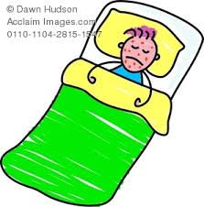
•Conjunctivitis (“pink eye)
•Whooping Cough
•Lice
•Measles
•Scabies
•Mumps
•Rubella
•Scarlet Fever
Unusual behaviors will be monitored closely, and parent(s) will be contacted if other symptoms develop. These behaviors include, but shall not be limited to:
•Cranky or less active behavior than usual
•Crying more than usual
•Feeling general discomfort or seeming unwell
•Loss of appetite

Children developing any symptoms that require dismissal or injured during the day, they shall be picked up by a parent since school does not have adequate isolation facilities. If we cannot contact a parent, we will call the emergency contact. Your emergency contact must be someone who can be available in case of mild illness, which would be available to provide temporary care for a sick child and has transportation to the preschool.

•Diarrhea: More than one abnormally loose stool
•Headache or stiff neck
•Severe Coughing
•Unusually dark, tea colored urine
•Difficult or rapid breathing
•Gray or white stool
•Severe itching of the body of scalp, or scratching of the scalp (may be symptoms of lice or scabies)
•Fever over one 100 degrees by mouth or 99 degrees under the arm
•Pink eye, tears, and redness of eyelid lining, irritation, followed by swelling or discharge of pus
•An infected skin patch(es) - crusty, bright yellow, dry or gummy areas of skin
•Unusual spots or rashes
•Vomiting
•Sore throat or trouble swallowing
•Yellowish skin or eyes
Children may return to school 24 hours after free of fever and symptoms. Children returning with any of the previous symptoms will be sent home. When your child is ready to return, and medication is required, a “Medication Authorization” form must be completed, signed by the parent so the office can administer the medication.

SAFETY POLICY
Grace Christian Academy has monthly practice fire drills and regular tornado drills. In the event of an actual weather alert, children will be kept in the building.

Threats: In the case of a threatening phone call or written message, the Director will be notified, and they will evaluate the threat, and if thought necessary, the police will be notified, and the center will follow their directions.

General Safety Practices:
•Children are always supervised, and teacher/child ratios maintained
•All staff members are mandated to report any suspicion of child abuse/neglect
•Parent emergency information on file
•Authorized pick-up information on file-if we are not familiar with the authorized pick-up person, we will ask to see identification and will match the person’s ID with the emergency information on file provided by the parent.
•Emergency numbers are posted by phones
•Emergency evacuation plans are posted in each room

TOBACCO FREE CAMPUS Our campus is tobacco free. No smoking, vaping, or dipping on the grounds of Grace Christian Academy

LIABILITY INSURANCE COVERAGE
Grace Christian Academy has the proper liability insurance for the center. Parents are responsible for individual medical insurance.
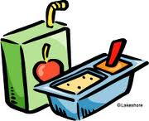
LUNCH AND SNACKS
Parents provide lunch. We ask that you provide a well-balanced nutritious meal. Please do not send candy in your child’s lunch. Gummies are allowed if they are made from 100% fruit juice. The center will provide a nutritious morning snack and drink.

Parent Involvement and Visitation Policy
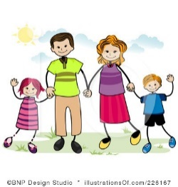
Your involvement early in your child’s life sets their course to succeed academically, it gives you a greater understanding of what goes into and occurs in our program, as well as a better understanding of your child’s growth and development. Grace Christian Academy Child Care Center has an open-door policy, and we encourage families to participate in their child’s learning.
Birthdays and Holidays
The most important occasion is a child’s own birthday. We want to celebrate birthdays!! We encourage parents to bring in commercially baked cupcakes, cake, cookies, and juice. The baked items must be in the original container showing ingredients used.

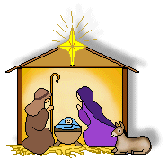
We celebrate Thanksgiving, Christmas, Valentine’s Day, and Easter. We will have class parties and ask parents to send items for the parties, as always parents are encouraged to attend. If you do not celebrate any of the above holidays, you will need to make other arrangements for your child, as we will be unable to provide other accommodations.

Items from Home
We understand some children have comfort blankets or bears that make them feel safe. We ask you not to allow your child to bring toys from home except on designated show and tell days.

Change of Clothing
Children are active and as a result, accidents sometimes happen. Please label and send a complete change of clothing for your child to use in the event of an accident. When used, please bring a replacement change of clothing. Your child’s required change of clothing should include shirt, pants, underwear, socks, and shoes. Be sure their clothes are easy to fasten and unfasten, as these are best for children learning self-help skills. Be aware of concerns if you allow your child to wear jellies, flip-flops, or any slide-on shoes, which could slip off when running or climbing. If your child needs a change of clothes and none are on site, you will be called to bring the clothes or pick up your child. The childcare center will not be responsible for damaged or lost clothing.

Discipline Policy
Praise and positive reinforcement are effective methods of the behavior management of children. When children receive positive, nonviolent, and understanding interactions from adults and others, they develop good self-concepts, problem solving abilities, and self-discipline. Based on this belief of how children learn and develop values, this facility will practice the following discipline and behavior management policy:
We:
1. DO praise, reward, and encourage the children.
2. DO reason with and set limits for the children.
3. DO model appropriate behavior for the children.
4. DO modify the classroom environment to attempt to prevent problems before they occur.
5. DO listen to the children.
6. DO provide alternatives for inappropriate behavior to the children.
7. DO provide the children with natural and logical consequences of their behaviors.
8. DO treat the children as people and respect their needs, desires, and feelings.
9. DO ignore minor misbehaviors.
10. DO explain things to children on their levels.
11. DO use short, supervised periods of “time-out”
12. DO stay consistent in our behavior management program.

We:
1. DO NOT spank, shake, bite, pinch, push, pull, slap, or otherwise physically punish the children.
2. DO NOT make fun of, yell at, threaten, make sarcastic remarks about, use profanity, or otherwise verbally abuse the children.
3. DO NOT shame or punish the children when bathroom accidents occur.
4. DO NOT deny food or rest as punishment.
5. DO NOT relate discipline to eating, resting, or sleeping.
6. DO NOT leave the children alone, unattended, or without supervision.
7. DO NOT place the children in locked rooms, closets, or boxes as punishment.
8. DO NOT allow discipline of children by children.
9. DO NOT criticize, make fun of, or otherwise belittle children’s parents, families, or ethnic groups.
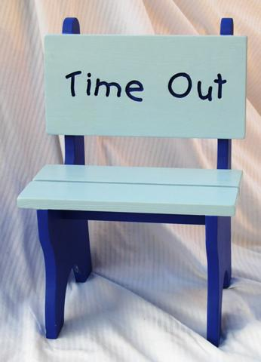
“Time-Out” "Time-out" is the removal of a child for a short period of time (generally 1 minute per year of age) from a situation in which the child is misbehaving and has not responded to other discipline techniques. The "timeout" space, usually a chair, is located away from classroom activity but within the teacher's sight. During "time-out," the child has a chance to think about the misbehavior which led to his/her removal from the group. After a brief interval of no more than 5 minutes, the teacher discusses the incident and appropriate behavior with the child. When the child returns to the group, the incident is over, and the child is treated with the same affection and respect shown to the other children.
Grace Christian Academy does not use corporal punishment as part of its disciplinary policy. Corporal punishment will not be administered at any time by the director or teacher/staff.

Biting Policy
Biting is very common in group settings of preschool age children. Yet, invariably, when it occurs, it is always disturbing to parents and caregivers alike. As with temper tantrums, we find that it is best to focus on prevention rather than waiting for the action to take place.
The following are some reasons a child may bite:
- A strong need for independence and control
- Feelings of frustration and anger
- Seeking attention
- Imitating another child’s behavior
- Self-defense when feeling possibly threatened by another child.

The staff of Grace Christian Academy MMO will be loving yet firm with children who bite. We will use some of the following procedures to work with a child who has a biting tendency, in addition to those disciplinary actions listed previously:
- Giving choices throughout the day that reinforce positive social behavior
- Giving children many opportunities to interact with each other along with special guidance to insure positive interactions
- Watching for signs of rising frustration and anger
- Giving children lots of attention throughout the day
- Modeling loving, supportive behavior
- Offering positive alternatives for negative behavior
- Providing support and assurance so that the child recognizes that they and their possessions are safe

A Final Word and Thank You
We are a Christian Education Program, and we want the children to know that God loves them. Our Christian staff will be teaching the children all about Jesus and how He teaches us through the Bible to know and serve Him. It is our prayer that each child in our program will come to know Jesus Christ as his or her Lord and Savior at a young age.

Thank you in advance for your interest and cooperation with our program. We hope you will find our Center to be a warm and caring place for your child.

